|  |
| --- |
| OpenIDConnect |
| Google OAuth2 |

Abstractt

Google offers a Spring-centric tool to provide OAuth2 protection, called OpenIDConnect. There are three form-factors that Google’s OpenIDConnect OAuth2 product supports:

Android devices

iOS devices

ßrowsers (User-Agent)

This document explores how to register the latter User Agent – a browser.

NB Because of the very nature of a browser, please clear cache for the browser on successive sessions “runs”. This assures that you are accessing the OpenIDConnect-protected application in a way that consistently presents a modal login (challenge-response) dialog box.

Setup, Examplet

The screen shot below shows a completed Credential entry for a web application in the Google Developers API Console.

Notice that the value in the **Name** column becomes the title of the challenge/response login page.

The value in the **Client ID** column below becomes the Key part of the K/V pair in the Spring‘s canonical application.properties file. This mapping, along with four other mappings, is shown later in this doc.

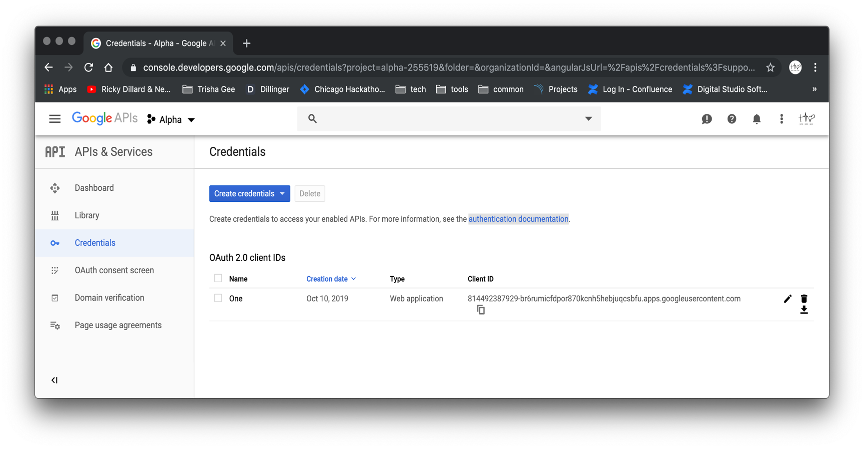

Setup, Processt

The section illustrates how to create a Credential in Google’s OpenIDConnect OAuth2 product.

Below, choose the **OAuth client ID** option from the Create credentials pick list.



Below, choose the **Web application** radio button (option) in the **Application type** section.

Then, supply this value for the **Authorized redirect URIs** textbox:

<http://localhost:8081/google-login>

Click the Create button.



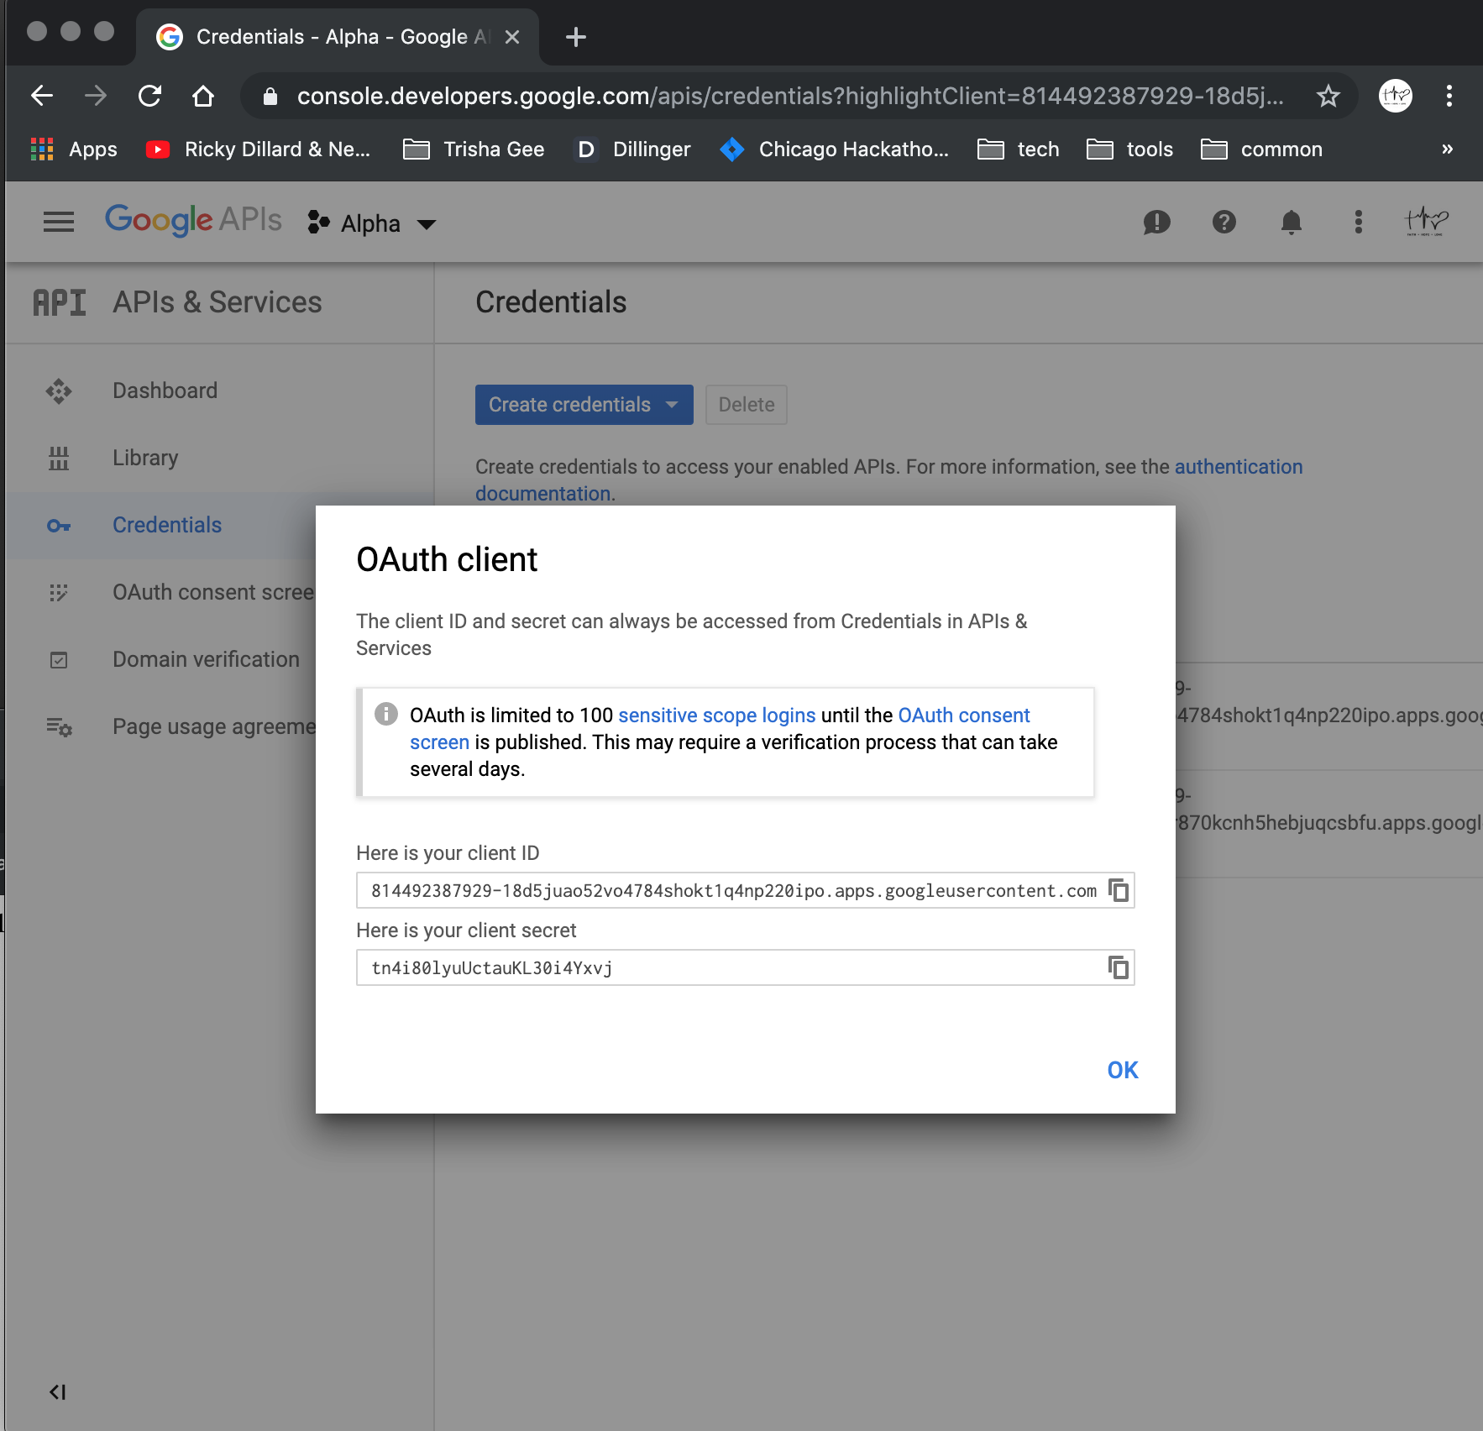

The pair of values generated by the Google’s OpenIDConnect OAuth2 product are used as entries in Spring’s canonical application.properties file.

They are the Client ID and the Client Secret.

The screen shot below shows a second, completed Credential entry in the Google Developers API Console, for the web application that we just registered.

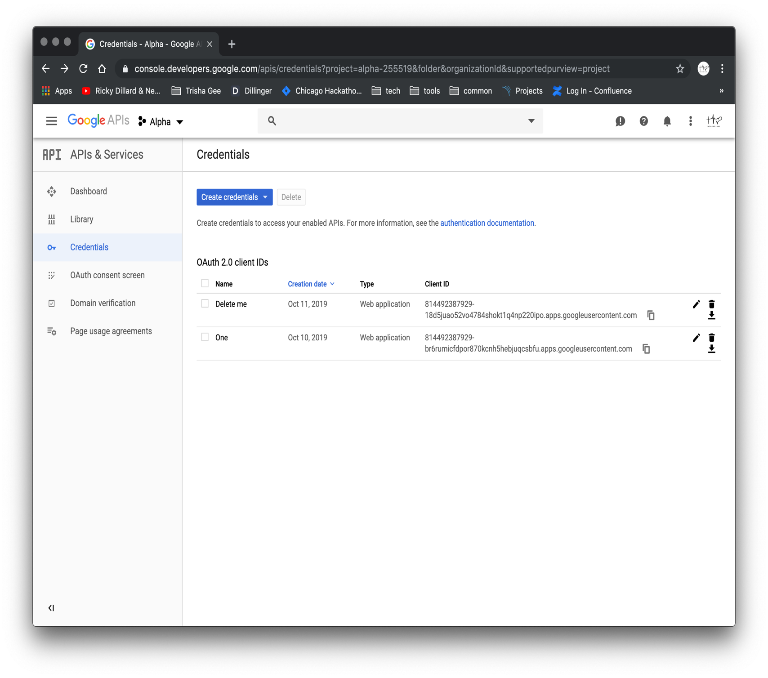

Usaget

The link for ingress into the OpenIDConnect-protected demo app is (by configurable design):

<http://localhost:8081/google-login>

|  |  |
| --- | --- |
|  |  |

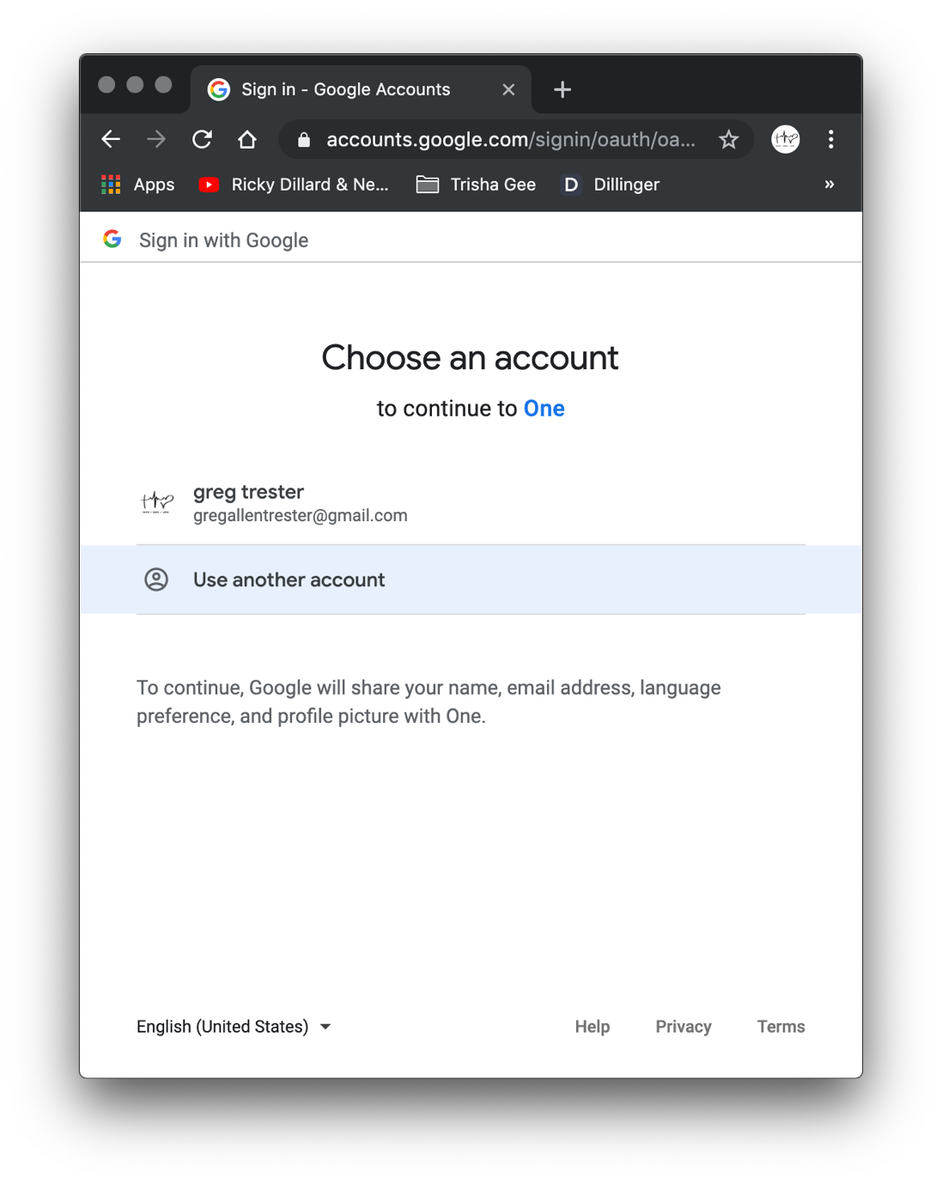

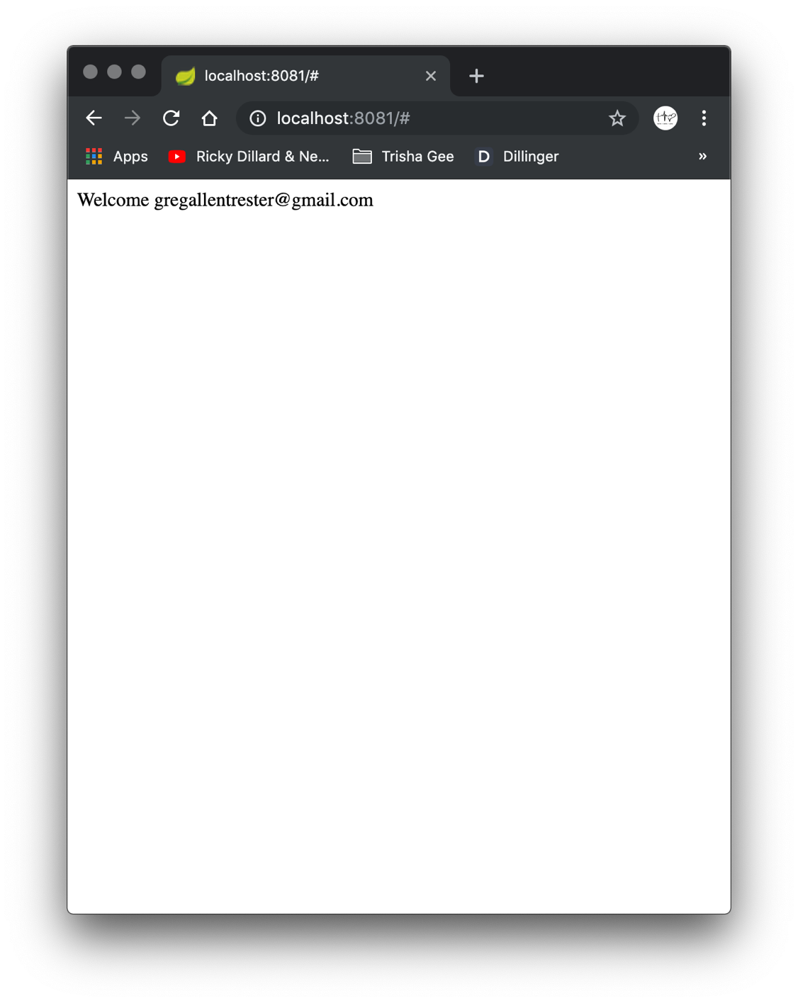

The applications’ console readout shows that a secure password has been generated (at the application/session scope); ACLs are not a part of the constraints being applied (for that, adopt the concept of a Principal).

The concept of Principals provides an affordance of a standardized way to enforce a finer granularity of access to application assets – View/Update/Delete –

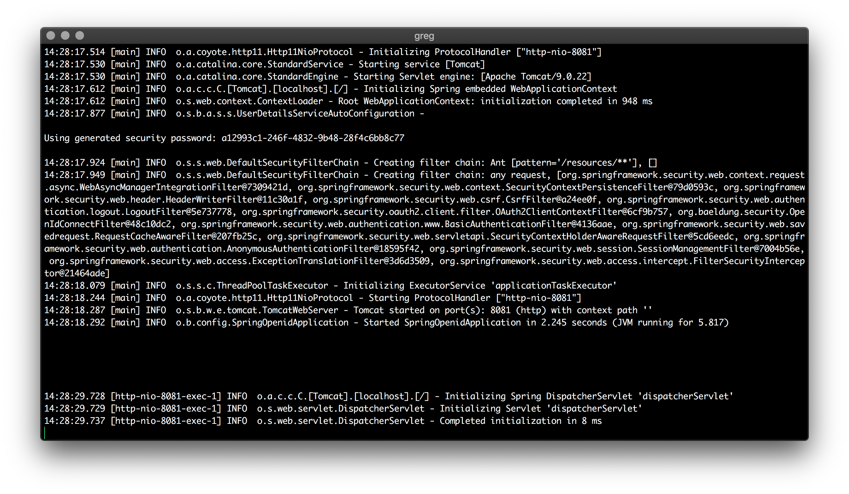

The Codet

A Java application’s part of the contract with OpenIDConnect is relatively unobtrusive.

The Spring Boot demo application that is discussed in this document uses a few annotations and some (5) entries in the canonical application.properties file.

NB In production, the application.properties file should have “locked-down” read only file permissions (e.g. 400).



Notice above, that the values for the clientId and the clientSecret keys (lines 3 & 4, respectively) must match the values that were auto generated in the Credential section of the OpenID Console.

ßuild-Runt

If you happen to have not stopped the Spring-boot application gracefully, the script show next will identify and kill your Spring-boot application.

Then, it compiles and executes the app by simply “sourcing” the script (w/o an extension, named:

ok

After killing the errant Spring-boot app, the ok script makes a delegating call to:

mvn spring-boot:run

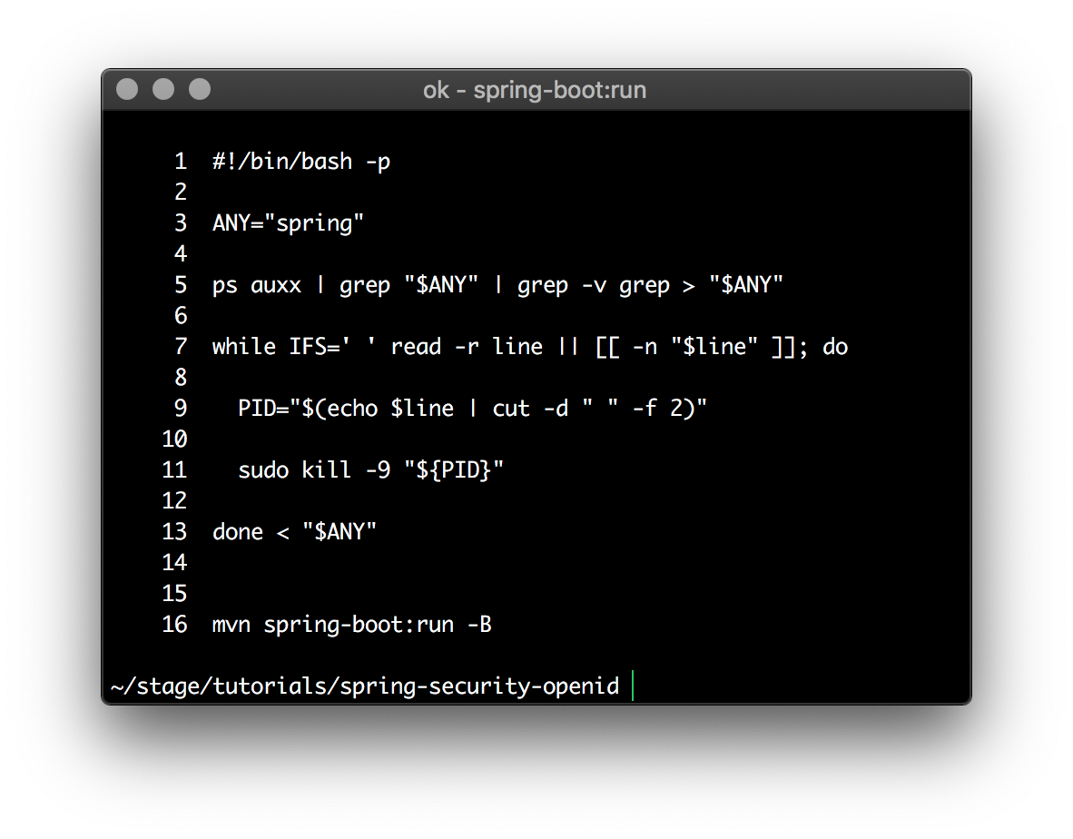

BTW, you can modify Line 3 in the above script to point to a fragment-of-a-name of any runtime image/process (ps, or process status).

Addendumt

These links originate with Google; however, they represent best-practices for the OAuth2 topic.

<https://developers.google.com/identity/protocols/OpenIDConnect#consentpageexperience>

<https://developers.google.com/identity/protocols/OAuth2?hl=en_US>

<https://openid.net/connect/>

<https://developers.google.com/identity/protocols/OpenIDConnect>

<https://github.com/eugenp/tutorials/tree/master/spring-security-openid>

<https://console.developers.google.com/apis/credentials?project=firstproject-98293&folder&organizationId>

<https://console.developers.google.com/apis/dashboard?project=firstproject-98293>

<https://developers.google.com/identity/protocols/OpenIDConnect#validatinganidtoken>